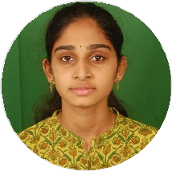Gayathri Kirala

A self motived individual looking for an opportunity to build career in a growing organization ,and climb the career ladder through continuous learning and commitment.

 [gayathrikirala@gmail.com](mailto:gayathrikirala@gmail.com) 7396635294

 12-139,Behind Annapurnamma Temple,Pentapadu, Tadepalligudem, India

# EDUCATION

## Study Program

### Sasi Institute of Technology and Engineering

*Tadepalligudem,Andhrapradesh Btech(pursing 2 year)*

Computer Science and

Technology

# ACADEMIC QUALIFICATION

## HSC

### Aditya Junior College

*06/2018 - 04/2020*, *Tadepalligudem*

*9.7 1 GPA*

# SKILLS

HTML

CSS

JavaScript

**PARTICIPATIONS**

Actively hosted Engineer's day celebration and been part of all activities.

At College Level.

# LANGUAGES

## SSC

### St.Jones English Medium School

*06/2017 - 04/2018*, *Tadepalligudem*

*9.7 Gpa*

English

*Full Professional Proﬁciency*

# INTERESTS

Telugu

*Full Professional Proﬁciency*

Solving Puzzles